**Samlet Use Case**

A customer wants to buy an Washcard that contains a value of washes for 200 -1000 kr.

When customers want to wash their car; they insert their card into the machine and chose a specific wash type. The price of the wash is then deducted from the card.

Customers can recharge their card with an amount up to 1000 kr by inserting their credit card and their WashCard into the machine.

Customers can check the amount left on their card by inserting it into the machine.

Customers can have a receipt printed if they wish

The Owner would like to have statistics of the washes

The System should be able to handle wash types and prices

**Use Case 1: Buy Washcard**

**Actor: Customer**

A customer wants to buy a Washcard that contains a value of washes for 200-1000 kr. Customer can buy the card online or on site. Address and name is required can add mail and phone number if customer wants. Amount varies between 200-1000 kr.

**Use Case 2: Recharge Washcard**

**Actor: Customer**

The customer can recharge the washcard by inserting the washcard into the machine and selecting “Add funds” option. Customer decides of the amount they want to add to their washcard. Inserts their credit card in the machine and funds are added to the washcard. Customer can get a print of the transaction and new balance if desired.

**Use Case 3: Check Balance**

**Actor: Customer**

The customer wants to check the balance of his card. Inserts the card in the machine.

The account number and name of the customer together with the balance is displayed. Customer can get a printed receipt if desired.

**Use Case 4: Buy wash**

**Actor: Customer**

The customer wants to buy a wash. Customer inserts the card into the machine. Balance is show along with selection of avail

able washtypes. Customer selects the desired washtype, amount is deducted from his account and the wash is initialized. Customer can get a print of price of the selected wash and with the new balance of the wascard, if desired.

**Nouns:**

Washcard Print

Balance Amount

Recharge Price

Customer

Name

Account number

**Verbs list:**

Add to balance

Check balance

Print receipt

Recharge Card

Get price

**FURPS+   
Af Carwash**

Functional—features, capabilities, security.

* Different types of wash, with pricesetting
* Physical washcard
* Add funds to washcard
* Check balance of washcard
* Printed receipt
* Check balance and more in app

Usability—human factors, help, documentation.

* Human on-site support
* In depth description of selected wash
* Description of products used
* Human advisor available on site.

Reliability—frequency of failure, recoverability, predictability.

* >95% uptime, with possible offline availability
* Backup of accounts on a daily basis
* Mechanical errors handled swiftly by personell on site.
* Monthly review of performance, improvement, downtime, feedback etc.

Performance—response times, throughput, accuracy, availability, resource usage.

* < 1 sec response time for selection on site.

Supportability—adaptability, maintainability, internationalization, configurability.

* Language select
* Android and IOS applicable
* Changes tested before rolled out to customers

**Domain model**

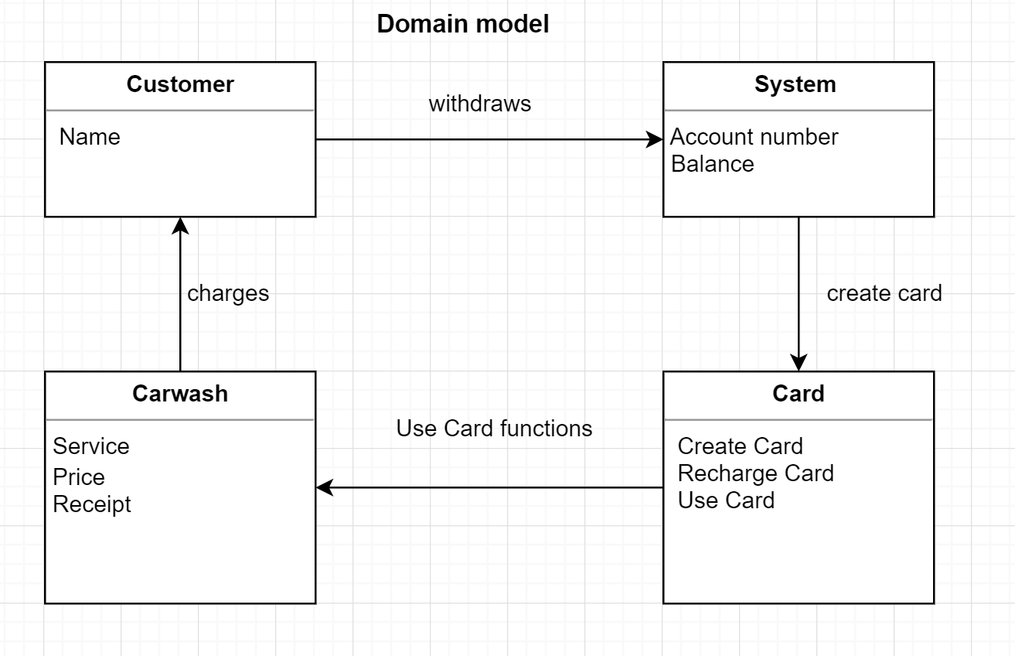

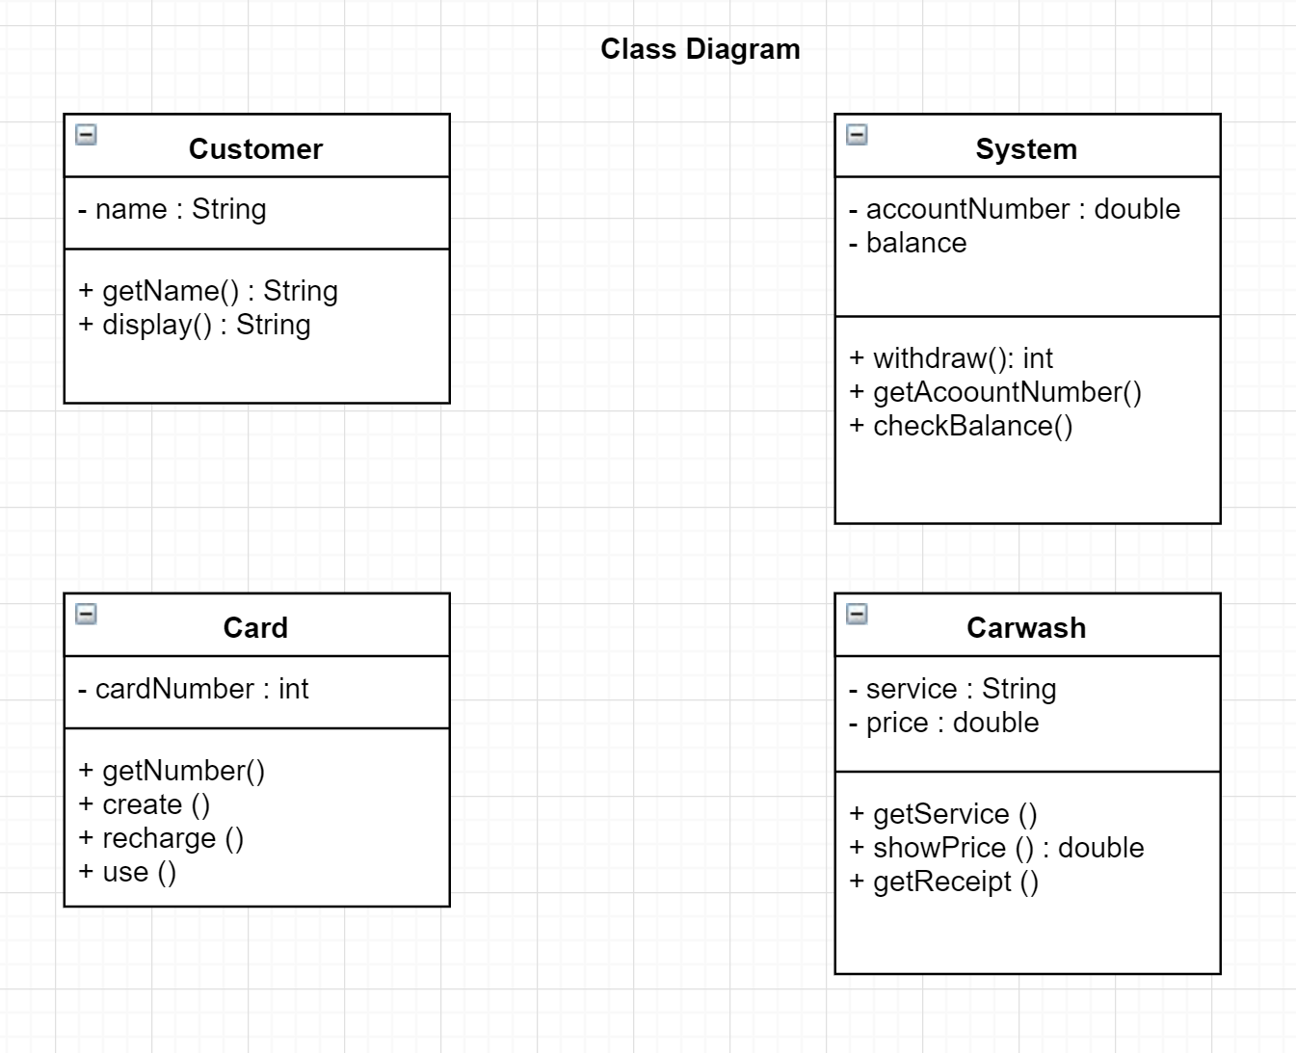

**Use case diagram**

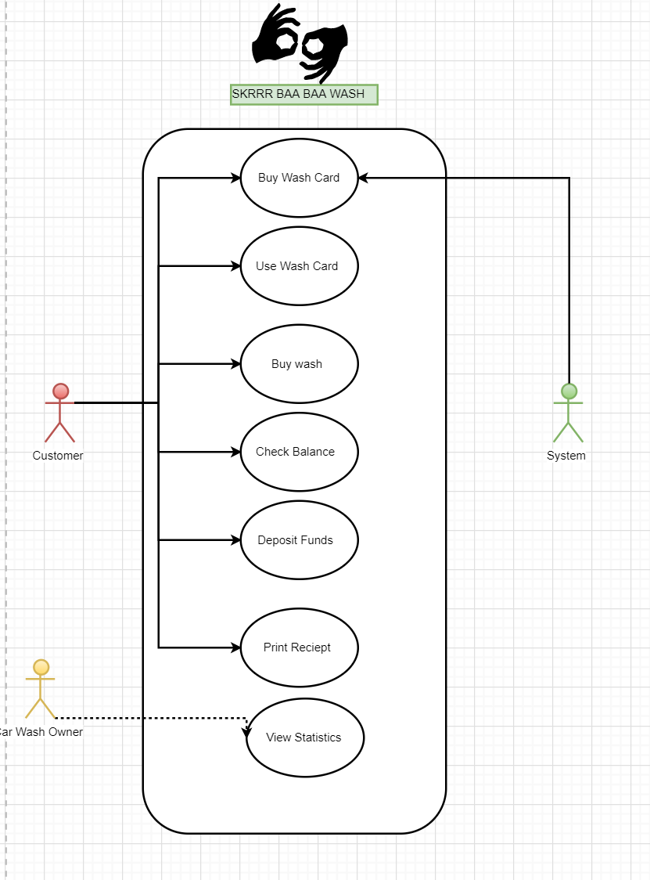

**SSD - System Sequence Diagram**

